**Maps_Geo_Tennis Court**

1. Mapping basics, built-in map view support

If you want to analyze your data geographically, you can plot your data on a map in Tableau. Mapping explains why and when you should put your data on a map visualization. It also describes some of the types of maps you can create in Tableau, with links to topics that demonstrate how to create each one. Mapping in tableau allows you to view sections of data by customizing based on regions etc.

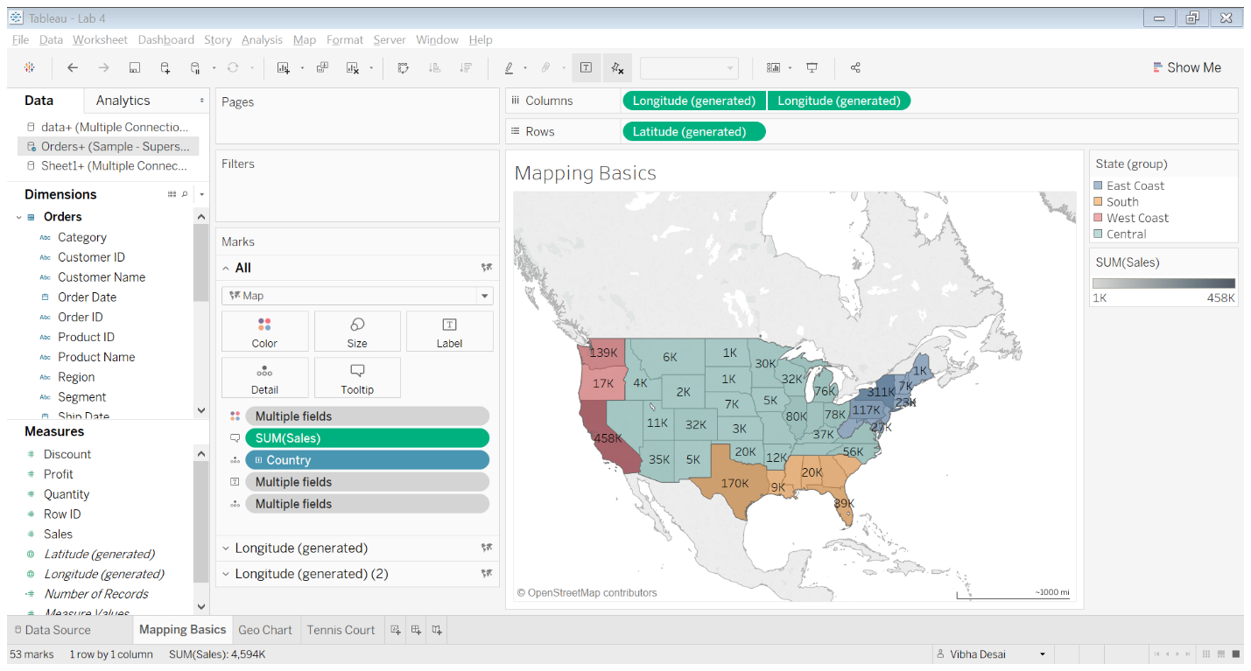

Figure 1: Sales in US regions

1. Geo Chart (tiled map)

The data used here has Student Debt information in one sheet and Hexmap plots in another sheet. The join created using these two sheets is used to plot this hex-tile map.

The student debt data sheet had irrelevant data and null fields which was fixed before importing into Tableau. The ten-year change in student debt was plotted based on US states.

The reasons to use hex-tile maps are to:

* Eliminate the Alaska effect on US maps
* Eliminate discrepancies in US state sizes
* Provide a more modern web look

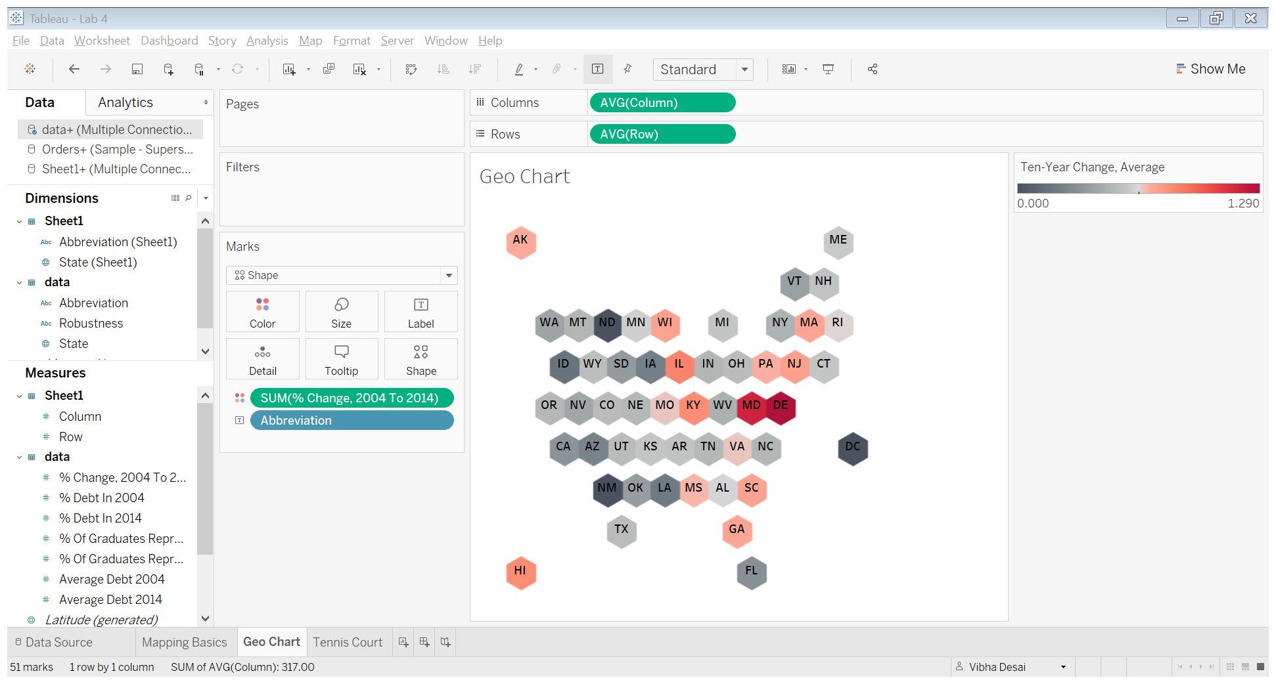

Figure 2: Hex-tiled map showing change in student debt

1. Custom Map building using polygons and images

Polygon maps in Tableau are created by looking up the coordinates of the shape you want to draw, and then connecting the dots by drawing a path between them. The description of a polygon map is that you “close the loop” around the dots by choosing a polygon mark type.

To create a tennis map as shown in the image below:

* Start by adding the given data into an excel sheet.
* Derive the coordinates using the drawing tool.
* Save the coordinates in a .csv file.
* Join the excel sheet and .csv file.
* Plot X and Y on the graph, select back ground image of the tennis court (already provided).
* Drag Region to Detail and Path ID to path and Winning Percentage (AVG) to color.
* This derives the tennis court shown below.

